1. How are inline and block elements different from each other?
Inline components don't begin on new lines. It implies that they'll arrange directly beside one another on a similar line if there's sufficient space for them.
As a matter of course, block level components take up its whole width parent compartment. After it's arrived at the edge of the compartment it'll dip under different components. So on the off chance that you've quite recently got a section in the <body>, at that point it will take up the whole width of the browser, except if you've set a width for the body.

2. Explain the difference between visibility:hidden and display:none
display:none implies that the tag being referred to won't show up on the page by any stretch of the imagination (despite the fact that you can at present connect with it through the dom). There will be no space dispensed for it between different tags.
visibility:hidden implies that dissimilar to display:none, the tag isn't obvious, however space is apportioned for it on the page. The tag is rendered, it simply isn't seen on the page.

3. Explain the clear and float properties.
The float property is utilized for situating and arranging content for example let a picture float left to the content in a holder.
The float property can have one of the accompanying qualities:
• left - The component floats to one side of its compartment
• right - The component floats to one side of its compartment
• none - The component doesn't float (will be displayed exactly where it happens in the content). This is default
• acquire - The component acquires the float estimation of its parent
Float is utilized to move substance left or right and to stop it we utilize clear as a boundary. On the off chance that a component can fit in the level space by the floated components, it will;unless you apply the unmistakable property to that component a similar way as the float. At that point the component will move beneath the floated components.

4. explain difference between absolute, relative,fixed and static.

• Static - this is the default value, all components are all together as they show up in the archive.

• Relative - the component is situated relative to its normal position.

• Absolute - the component is situated absolutely to its firstly situated parent.

• Fixed - the component is situated identified with the browser window.

5. Write the HTML code to create a table in which there are 4 columns( ID , Employee Name, Designation, Department) and at least 6 rows. Also do some styling to it.
<!DOCTYPE html>
<html>

<head>
<title>Q5 Table</title>
<style type="text/css">
td {
text-align: center;
}
</style>
</head>

<body>
<table border="1" style="width: 100%">
<thead>
<tr>
<th>ID</th>
<th>Employee Name</th>
<th>Designation</th>
<th>Department</th>
</tr>
</thead>
<tbody>
<tr>
<td style="color: blue; font-weight: bold;">001</td>
<td>Rahul</td>
<td>qe</td>
<td>cse</td>
</tr>

<tr>
<td style="color: blue; font-weight: bold;">002</td>
<td>Rohan</td>
<td>Rohit</td>
<td>ece</td>
</tr>
<tr>
<td style="color: blue; font-weight: bold;">003</td>
<td>prabhav</td>
<td>ame</td>
<td>mec</td>
</tr>
<tr>
<td style="color: blue; font-weight: bold;">004</td>
<td>Reema</td>
<td>react</td>
<td>civil</td>
</tr>
<tr>
<td style="color: blue; font-weight: bold;">005</td>
<td>Revti</td>
<td>game</td>
<td>unity</td>
</tr>
<tr>
<td style="color: blue; font-weight: bold;">006</td>
<td>Raman</td>
<td>cyber</td>
<td>analyst</td>
</tr>
</tbody>
</table>
</body>

</html>
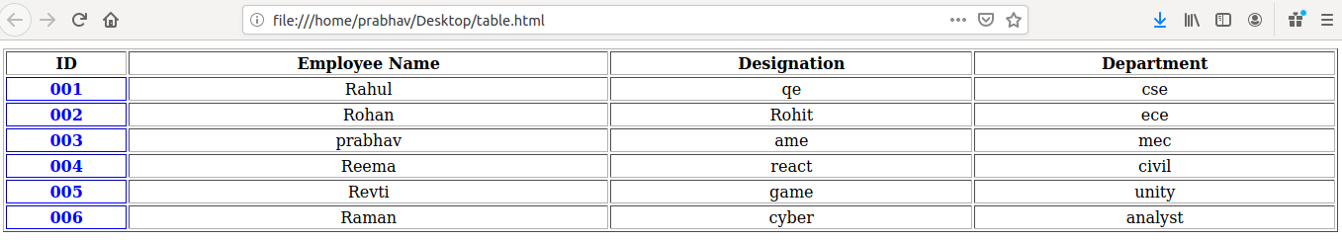
6. Why do we use Meta Tags?
The importance of meta tags is that the search engines read them in order to compare if these keywords and the description are related to the visible content.

7. Explain box model.
All HTML elements can be considered as boxes. In CSS, the term "box model" is used when talking about design and layout. The CSS box model is essentially a box that wraps around every HTML element. It consists of: margins, borders, padding, and the actual content.

8. Explain 5 HTML5 semantic tags.

- CSS Element Selector
The element selector selects the HTML element by name.
- CSS Id Selector
The id selector selects the id attribute of an HTML element to select a specific element. An id is always unique within the page so it is chosen to select a single, unique element.
- CSS Class Selector
The class selector selects HTML elements with a specific class attribute. It is used with a period character . (full stop symbol) followed by the class name.
- CSS Universal Selector
The universal selector is used as a wildcard character. It selects all the elements on the pages.
- CSS Group Selector
The grouping selector is used to select all the elements with the same style definitions.
Grouping selector is used to minimize the code. Commas are used to separate each selector in grouping.

9. Define Doctype.
The <! DOCTYPE> declaration is an instruction to the web browser about what version of HTML the page is written in. It helps the browser to know what type of document to expect.
10. Explain 5 HTML5 semantic tags.
1- The <article> element specifies independent, self-contained content.
2- The <section> element defines a section in a document.
3- The <header> element specifies a header for a document or section.
4- The <footer> element specifies a footer for a document or section.
5- The <nav> element defines a set of navigation links.

11. Create HTML for web-page.jpg (check resources, highest weightage for answers)
Codes are in the same folder in form of html and css files.
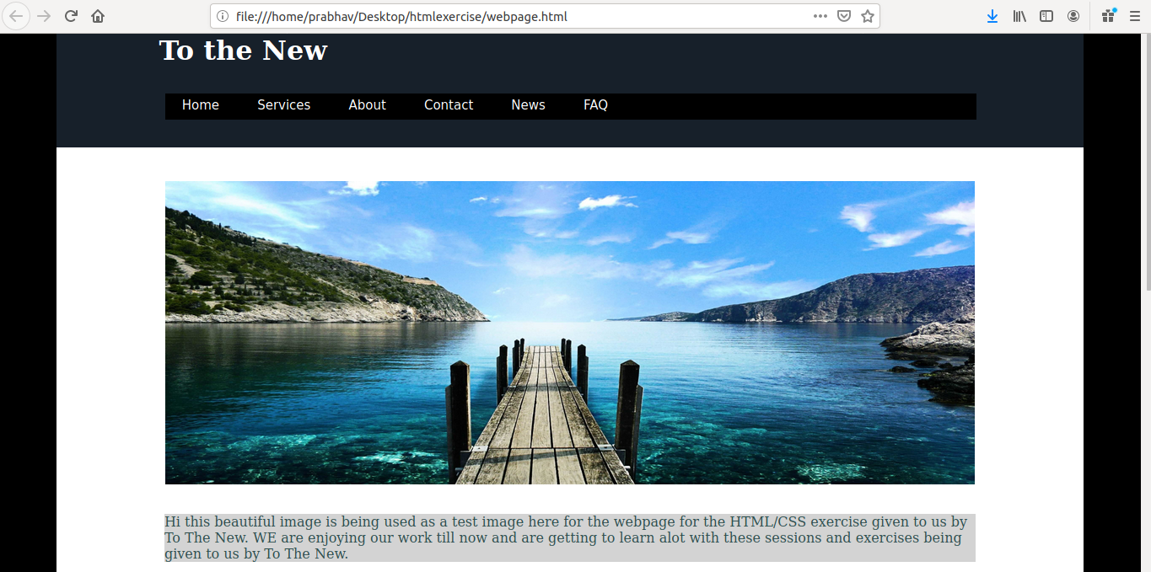
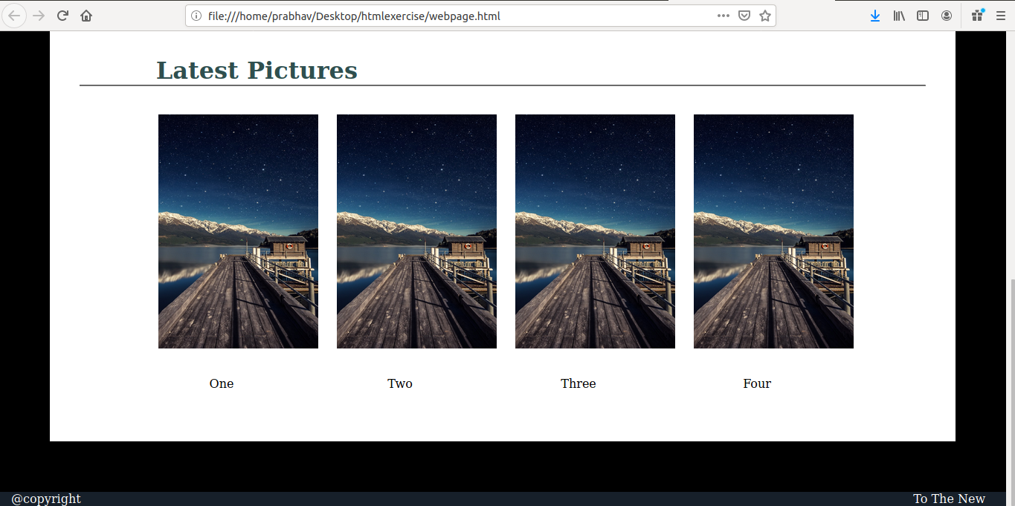

12. Create HTML for form.png (check resources, highest weightage for answers)
